VARSITY COLLEGE DURBAN NORTH opsc7312

Duran Moodley 13016335

Assignment 1-POE

Contents

Introduction 2

Program Specification 2

App Description 2

Functionality 2

System Requirements 2

Website/Backend 3

Flow Chart 5

Android App 5

Website 10

UML Diagrams 13

Class Diagrams 13

Use Case Diagram 15

Sequence Diagram 16

Database Design 18

ERD 18

Table Design 18

Help File 19

Screenshots 20

Android Application 20

Website 26

Lecturer Feedback & Corrections Made 27

Conclusion 28

Problem Statement

# Introduction

Varsity College lecturers find it difficult and tedious to record student attendance. Currently, a manual process is used whereby lecturers receive a register. This register contains the names and student numbers of all the students. Each student must sign their initials. The lecturers would like an app that can verify if a student is on campus.

# Program Specification

## App Description

This app should be able to retrieve the location of the student and check if it matches the campus address. If it does, the relevant data will be saved to a database. The data that will be saved will include: the student number, the date and time and the module code that the student attended. The students should be able to check in and check out. Check in will verify the students location. If the student is at the designated venue their student number, attendance time, date and module will be saved to an online database. Check out will then verify if they are at the location and then save their check out time from the lecture. Lastly, the lecturer should also be able to generate a report of the students who attendance a particular module. The student will also be able to view their attendance record on the application.

## Functionality

* Retrieve location using geocoder and Google api (Fused Location Provider)
* Show google Map and draw polylines tracking the students movements
* Saved data to an online database hosted on awards space
* Created a php scripts that communicates with android app and MYSQL database
* Made use of a JSON object to read the data from the MYSQL database
* Read from a text file
* Incorporated Geofencing into the project
* Display notifications to the user
* Incorporated Material Design into the application utilizing a Sliding Tab Layout
* Used Async task and Intent Service to reduce the work load on the Main UI thread
* Made use of share preferences to store data
* A website has been incorporated in the system. This allows lecturers to view reports. The data is retrieved from the online database
* Created store procedures in MYSQL

## 

## System Requirements

**Student Registration Start up Screen**

*This screen requires the student to enter in their basic details. These details include student number, student name and student course. This data will be saved to a shared preference and will later be sent to the database once the student has checked out. This screen will only appear and will never reappear unless the student uninstalls the app.*

***Student Main(Question 1)***

*This screen contains a sliding tab layout that contains 2 Fragments. The first Fragment (Check In) requires that the student first enter in the module that they are in. Provided that their location and wifi settings are on, they will be able to check in. A dialog box will be presented to prompt the user to turn on these settings. After clicking the red button, the location of the user is verified. Once a location has been found, the student can now close the app and return to it once the lecture has ended. Upon, closing the app, a notification will appear to remind the user to return to the app to check out. In addition, the app will also set a geofence after checking in. If the student leaves the geofence a notification will appear to notify the user to return to the lecture venue to check out. After checking out, the student’s details will get sent to the online database.*

*The Second Fragment (Report) contains a list view that contains the student’s information of the lectures he/she has attended. This allows the student to verify and view their attendance records.*

**Student Map (Question 2)**

*This screen contains a google map that locates the user. The map draws a poly line has the device moves.*

**Student Help**

*This displays a screen with information on how to use the application*

## Website/Backend

Web Site Link: http://duran.dx.am/attendanceRecord.php

The lecturer can also view a report of all the students’ attendance.

The lecturer can do the following on the website:

* Search for a particular students attendance records
* Search attendance for a module
* View all records

**Search Web Page**

*This presents the lecturer with search options. This includes: Student, Module or View all. Clicking on these options will redirect the lecturer to the designated web page.*

**Student Search Web Page**

*This presents the lecturer with a text field to enter in a student number. Clicking search will display a table with the student’s attendance record for all modules.*

**Module Search Web Page**

*This presents the lecturer with a text field to enter in a module code. Clicking search will display a table with all the attendance for the module code.*

**View All Attendance Web Page**

*This displays a list of all attendance for all modules and courses for every student*

# Flow Chart

## Android App

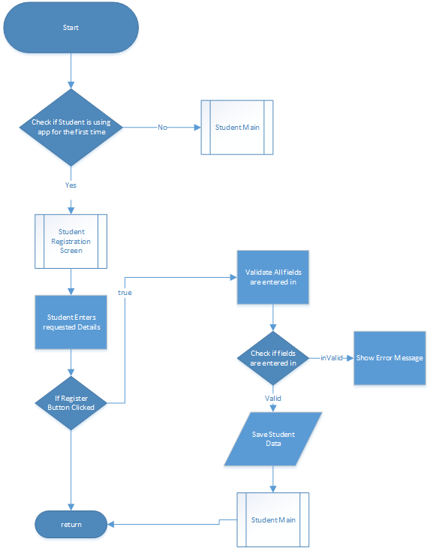

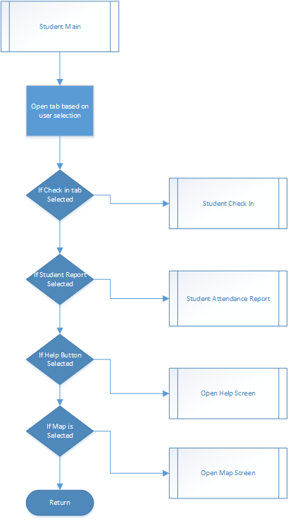

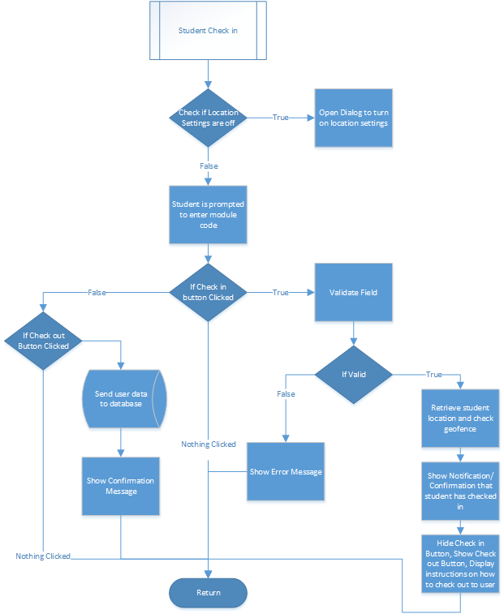

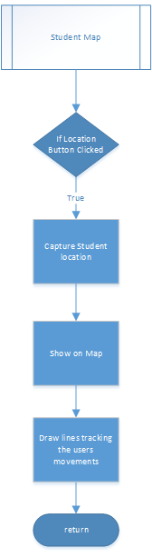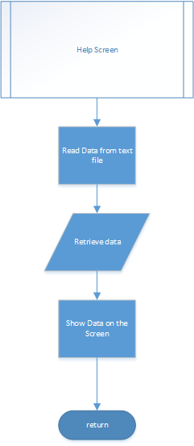

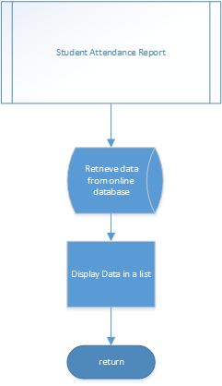

## Website

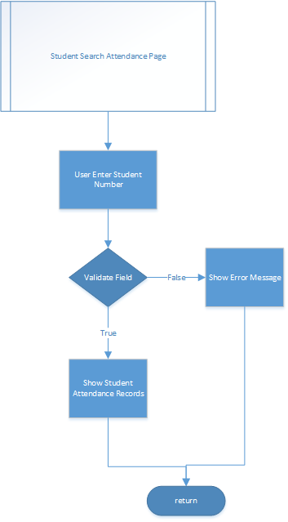

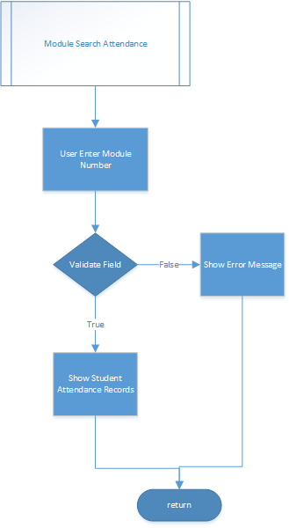

# UML Diagrams

## Class Diagrams







## Use Case Diagram





## Sequence Diagram





# Database Design

## ERD



## Table Design

|  |  |  |  |  |  |
| --- | --- | --- | --- | --- | --- |
| studentNumber{PK} | dateCheckIn | timeCheckIn | timeCheckOut | moduleCode | courseCode |
| 13016335 | 10/16/2016 | 12:00 | 13:00 | OPSC7312 | DISD3 |
| 14003989 | 10/12/2016 | 08:30 | 09:30 | SQUAT6312 | DISD3 |
| 13059695 | 10/09 | 08:30 | 09:30 | APPR7312 | DISD3 |
| 13016335 | 10/13/2016 | 12:00 | 13:00 | OPSC7312 | DISD3 |
| 14003989 | 10/21/2016 | 08:30 | 09:30 | WIL | DISD3 |

# Help File

This application has been created for the sole purpose of tracking student’s attendance.

At the start of the application, you had to enter in your basic details.

In order to successful track your attendance, you need to Check in and Check out by clicking on the Red Button.

However, this can only be achieved by first entering in the module code that you are checking into,

Secondly, you need to ensure that your location settings are on and that you are at your designated venue.

Once you have checked in you may close the application and return to it when your Lecture is complete and check out.

You will receive a notifications welcoming you to your venue and to remind you to checkout once you have checked in.

You may also view your own attendance report by selecting the report tab.

All your details will be sent to the administrative office for verification.

If there are any issues, please consult your lecturer.

# Screenshots

## Android Application

**Registration Screen**

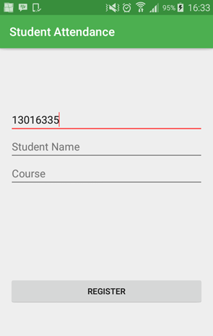 Requires the Students to enter in their basic student details

**Registration Screen - Validation**

If Student leaves a fields blank, an error message will appear

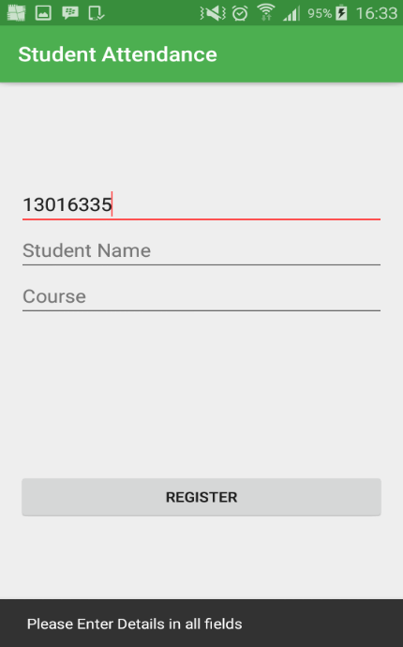

**Registration** **Screen**

Student is prompted to select the course that they are studying

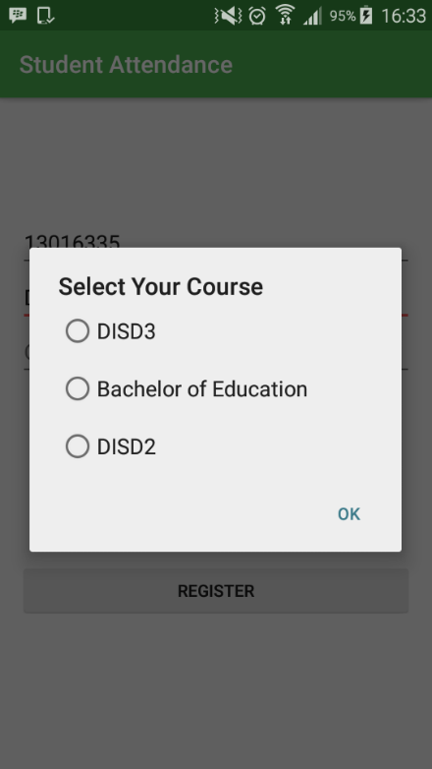

**Student Check in** **Screen**

If location settings are off, the student is prompted to turn on location settings

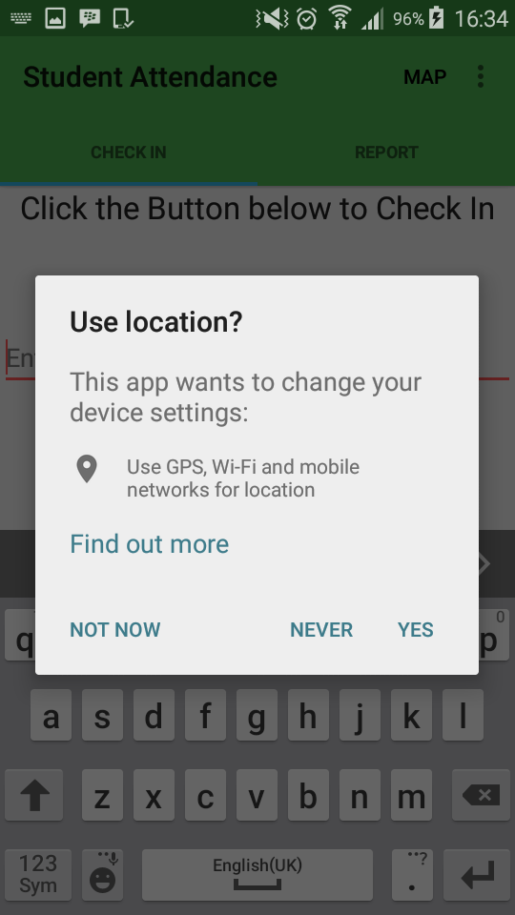

**Student Check in Screen**

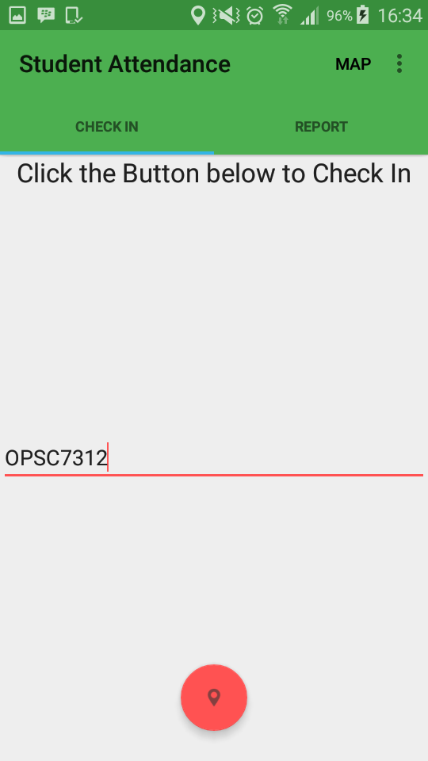 Student must enter in the module code that they are checking into

**Student Check in** **Screen**

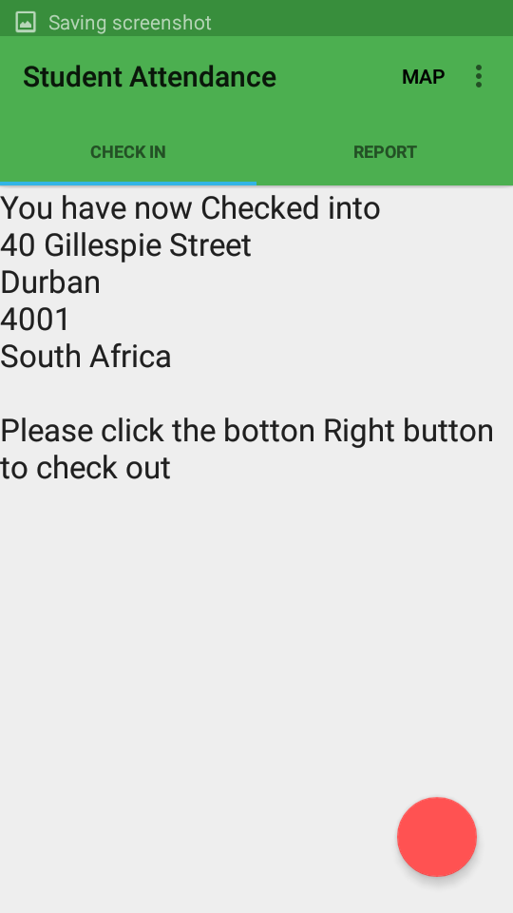Student has clicked the Check in button, the location of the student has been captured and displayed. This will be the address of the institute/university. This is for verification purposes.

**Student Check in** **Screen**

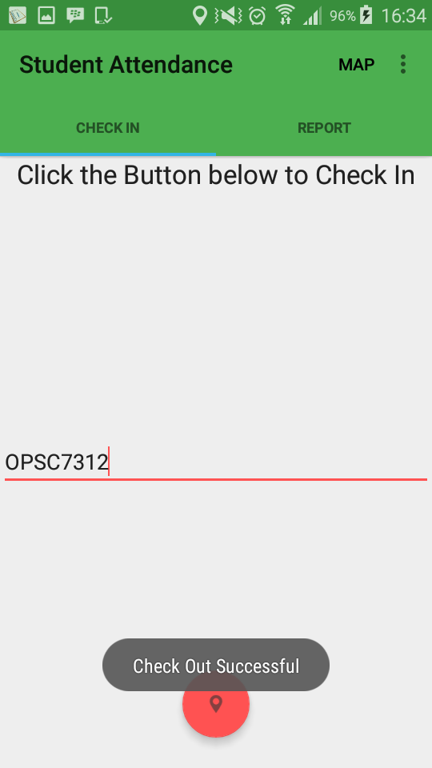 Student has successfully checked out, details of the student’s check in times, check out times, date, module and student number has been sent to the MYSQL database.

**Student Report**

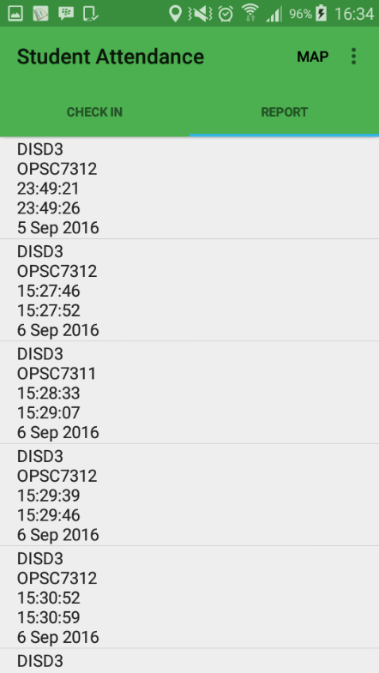 This shows the student all their attendance dates, check in, check out times and the module.

**Help Screen**

The student is provided with a help information on to use the app

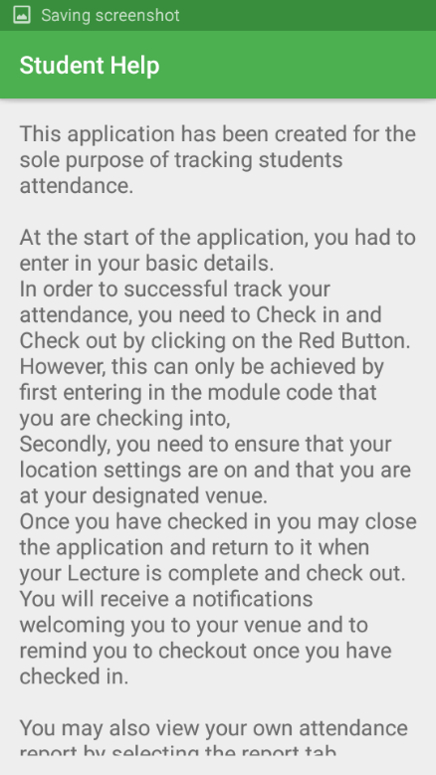

**Student Map**

Map showing students location

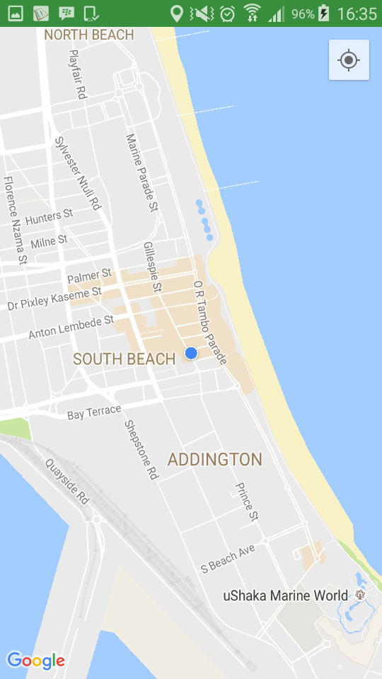

**Student Map – Polyline**

Application tracks users movements and draws it on the map

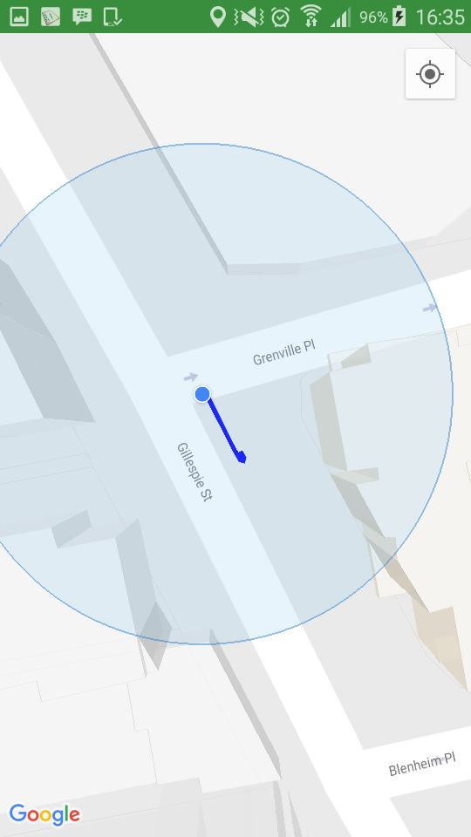

## Website

**Start Page**

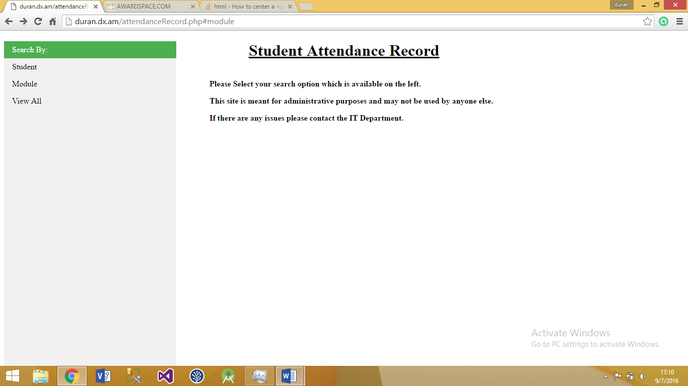Information to the administrator is shown on how to use the website to fulfil their tasks. On the left hand side, options are provided to allow the administrator to select a search option to view attendance reports according to their needs. Options include search by Student, Module or View All.

**Search by Student Page**

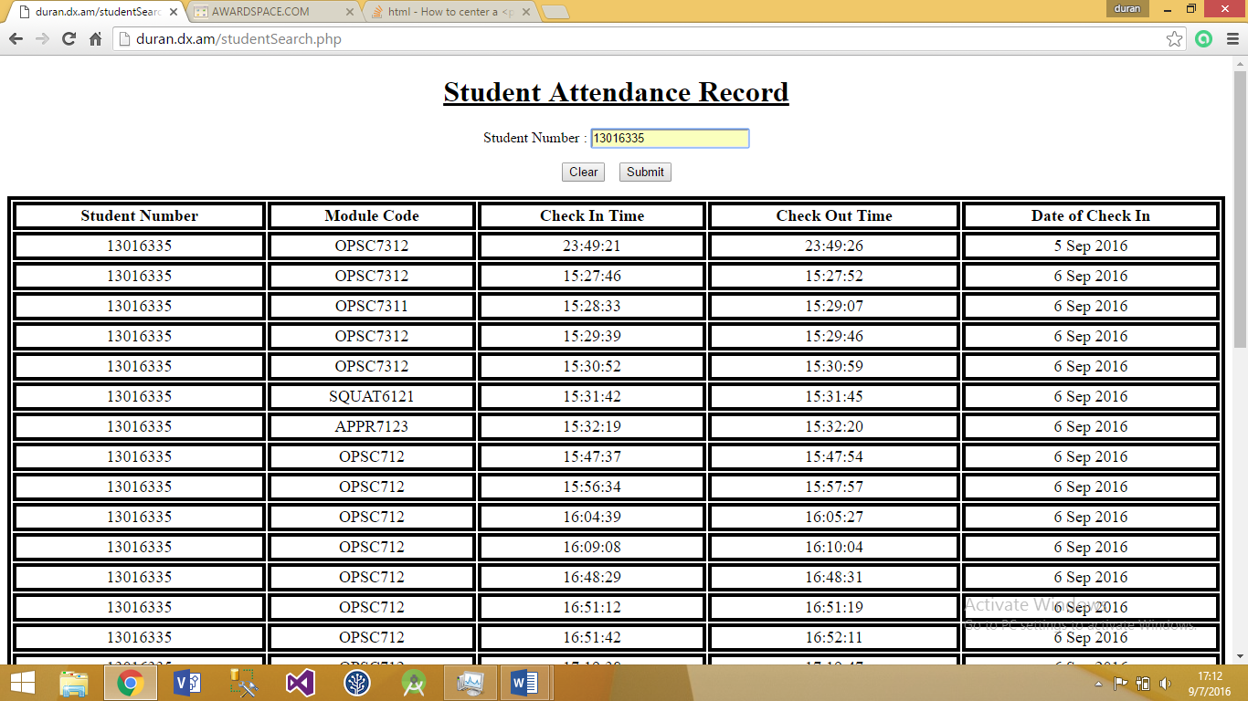Student Search can be done. The administrator must enter in the student number in the box provided. Clicking submit, will show all attendance records related to that student.

**Search by Module Code Page**

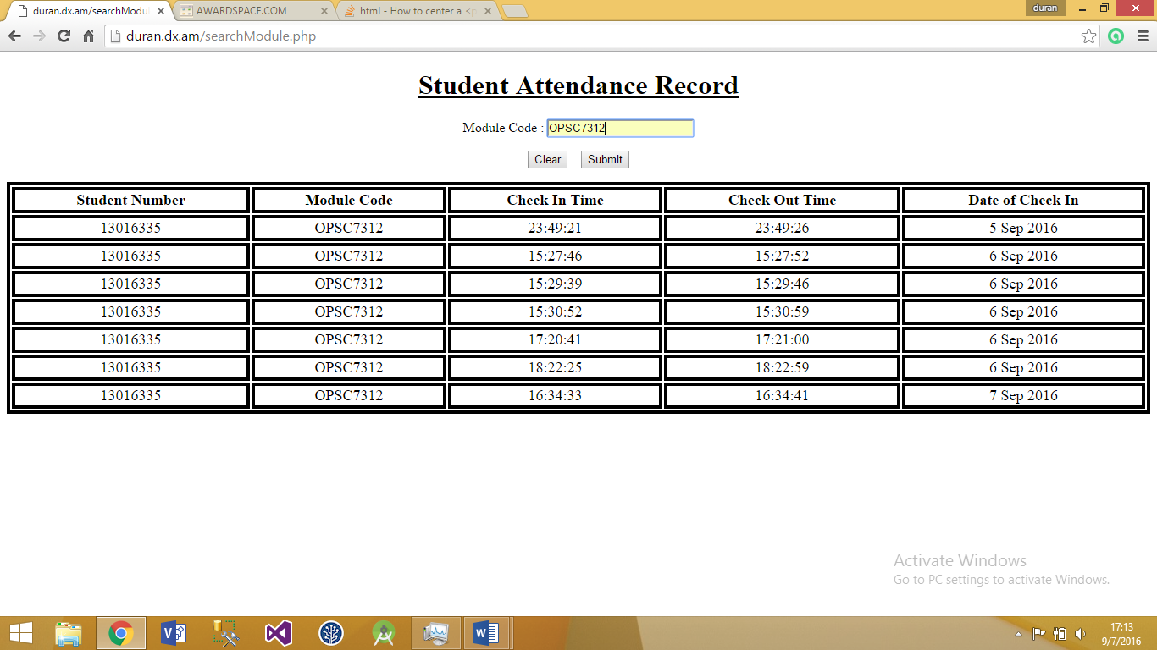Similar process as the student search. Administrator must now enter in the module code and will be shown all students who attended that module.

# Lecturer Feedback & Corrections Made

|  |  |
| --- | --- |
| Lecturer Feedback | Corrections Made |
| Some variables scope is too large | Made the appropriate variables local and reduced their scope |
| Use Date Time data type or alternative to store date/times | Not Fixed. |
| Comments are inconsistent | Added more comments to each class explaining certain blocks of code and the functions |
| Why not draw polylines from recorded lecturers | Polylines do track the student’s movements. |
| Report tab only updates when closing app and restarting – should update when an entry is made or when switching to the tab | Report Tab updates when the student has checked out. |
| Clicking on student notification does do anything. Should go to the app. | Removed Notification. |
| Could check out at a different address to the one used to check in. | Saved the students check in location and compared it to the students check out location. Both have to be the same in order for the student to check out. |
| Some redundancy where strings used eg. Checkout date could put into string.xml and referenced | Redundancy Removed. Strings added to strings xml file |

# Conclusion

This app challenged my knowledge and skill in android development. I was now exposed to the using google API, android API and connecting an android application to an online database. This assignment was a very rewarding experience has I had the opportunity to develop an application for a real client. I hope that this system can be used in a real world scenario and solve the problems that come with it.